**IIOT Assignment-11**

(Dheeraj Tiwari)

1. Perform an experiment to interface Ultrasonic sensor HC-SR04 and Relay with Arduino. For e.g. Relay activates when the distance measured by ultrasonic sensor is above 20cm.AC bulb should be connected to NO terminal of relay

Ans :

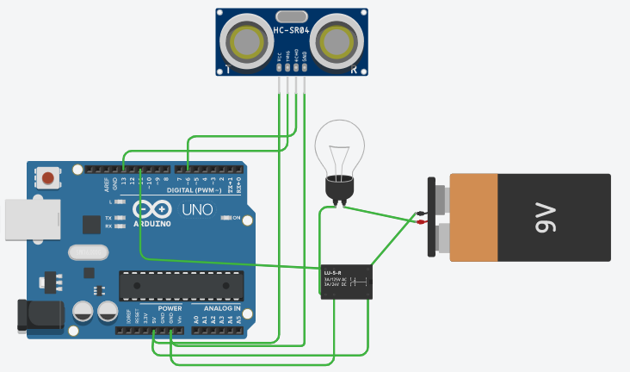

const int trigPin = 13;

const int echoPin = 6;

long duration;

int distance;

void setup()

{

pinMode(trigPin, OUTPUT);

pinMode(11, OUTPUT);

pinMode(echoPin, INPUT);

Serial.begin(9600);

}

void loop()

{

digitalWrite(trigPin, LOW);

delayMicroseconds(2);

digitalWrite(trigPin, HIGH);

delayMicroseconds(10);

digitalWrite(trigPin, LOW);

duration = pulseIn(echoPin, HIGH);

distance= duration*0.034/2;

if(distance > 20){

digitalWrite(11,LOW);

}else{

digitalWrite(11,HIGH);

}

Serial.print("Distance is");

Serial.println(distance);

Serial.print(" cm");

delay(1000);

}

1. Perform an experiment to control 5 LED’s and buzzer such that LED’s glow when the distance measured is below 10 cm and buzzer activates when the distance calculated is equal or above 10 cm.

Ans :

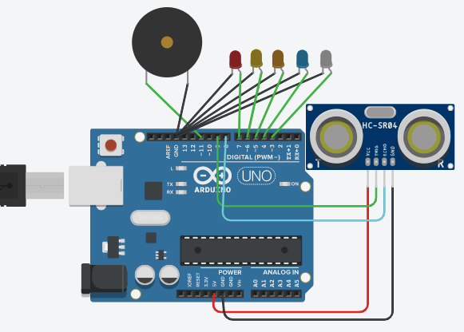

int leds[]={7,6,5,4,3};

int buzz=11;

int senTri=9;

int senEcho=8;

int distance;

int duration;

void setup()

{for(int i=0;i<5;i++){

pinMode(leds[i],OUTPUT);

}pinMode(buzz,OUTPUT);

pinMode(senTri,OUTPUT);

pinMode(senEcho,INPUT);

Serial.begin(9600); }

void loop()

{ digitalWrite(senTri,LOW);

delayMicroseconds(2);

digitalWrite(senTri,HIGH);

delayMicroseconds(10);

digitalWrite(senTri,LOW);

duration = pulseIn(senEcho, HIGH);

distance= duration*0.034/2;

if(distance < 25){

for(int i=0;i<5;i++){

digitalWrite(leds[i],HIGH);}

digitalWrite(buzz,LOW);

}else

{for(int i=0;i<5;i++){

digitalWrite(leds[i],LOW);}

digitalWrite(buzz,HIGH); }}

1. Perform an experiment to control two dc motors such that one dc motor moves in forward direction when ultrasonic sensor detects an object within 30cm and second motor moved in reverse direction when detects object above 30cm. Also display the value of distance on LCD Display.

Code :

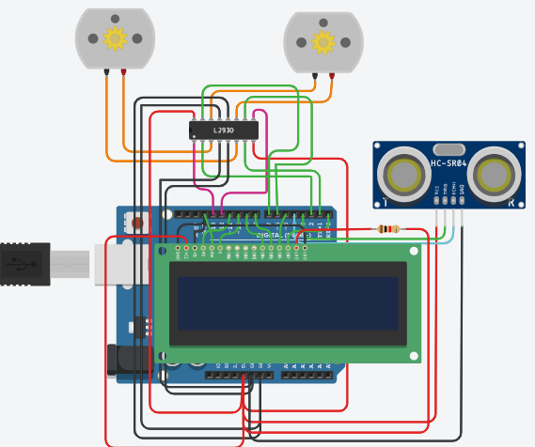

1. Explain the working principle of Ultrasonic sensor?

Ans : working principle

The ultrasonic sensor works on the principle of SONAR and RADAR system which is used to determine the distance to an object. An ultrasonic sensor generates the high-frequency sound (ultrasound) waves. When this ultrasound hits the object, it reflects as echo which is sensed by the receiver.

We need to transmit trigger pulse of at least 10 us to the HC-SR04 Trig Pin.

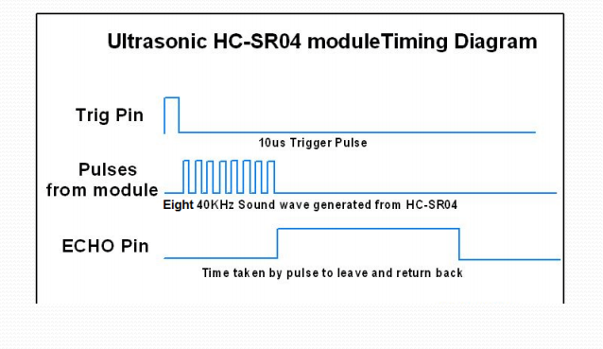

Then the HC-SR04 automatically sends Eight 40 kHz sound wave and wait for rising edge output at Echo pin.

When the rising edge capture occurs at Echo pin, start the Timer and wait for falling edge on Echo pin.

As soon as the falling edge is captured at the Echo pin, read the count of the Timer. This time count is the time required by the sensor to detect an object and return back from an object.